How to check your membership status for Social Care Ireland and update membership details.
- Go to www.socialcareireland.ie and on membership tab, click on current members
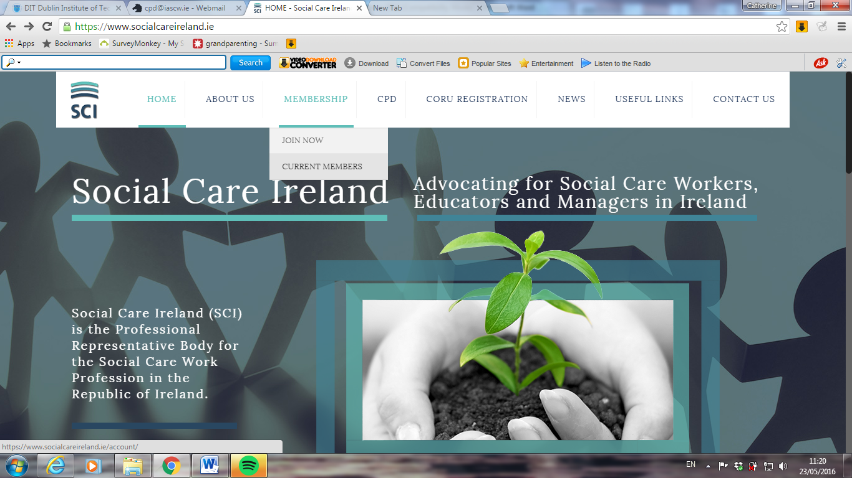

- Use your login in and password to sign into member area of website
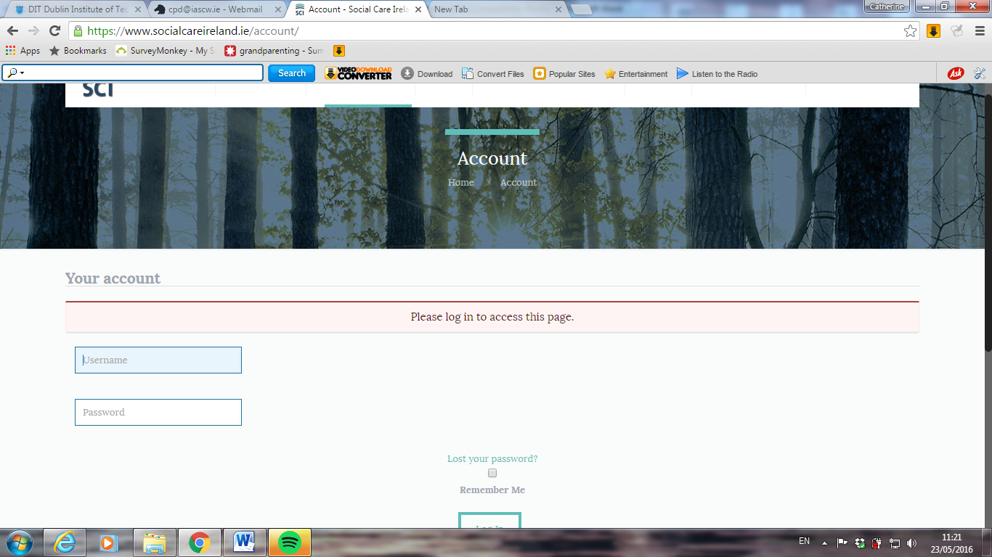

- Your membership status will show then. Click on pending button.
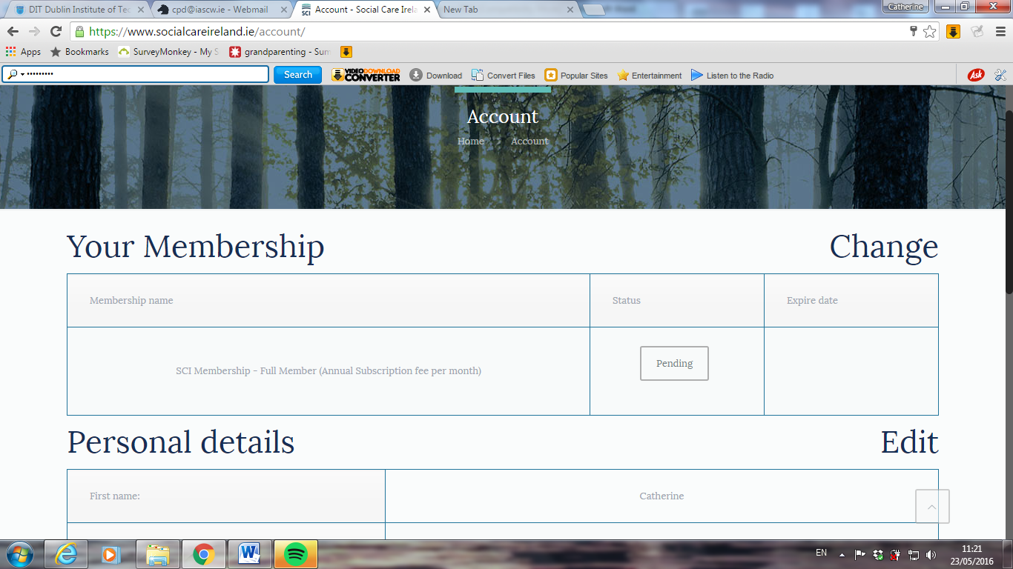

- This will open payment page and if you click on pay now, this will open credit/debit card payment.
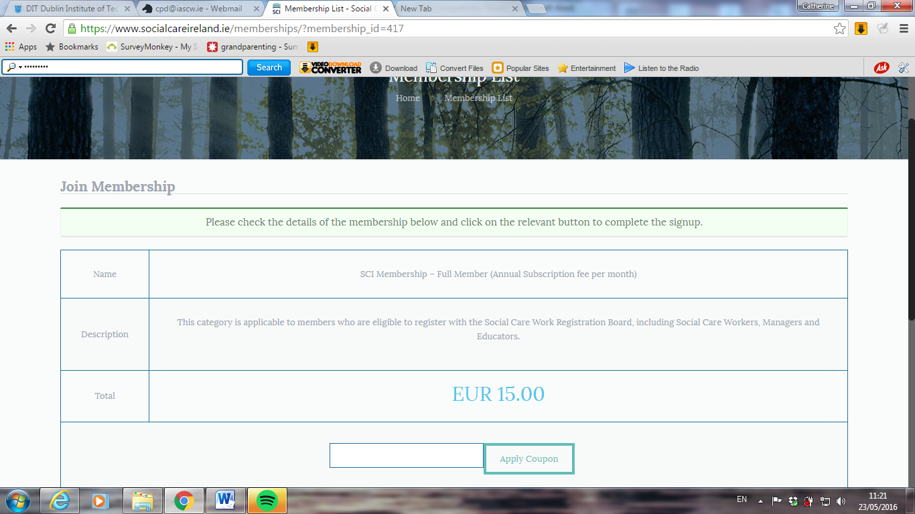

If you have selected to pay monthly the €15 per month will be deducted automatically from your account.
If you have any queries please contact cpd@iascw.ie.

